Slutsky decomposition
Authors:
Marcin Kasprzak (student number 386470)
Marta Socha-Jakubowska (student number 388278)
Natalia Trojakowska (student number 388403)

Ex. :
Assume a person has a utility function U = XY, and money income of
$10,000, facing an initial price of X of $10 and price of Y of $15. If the price of X
increases to $15, answer the following questions:
(a) What was the initial utility maximizing quantity of X and Y?
(b) What is the new utility maximizing quantity of X and Y following the increase in
the price of X?
(c) What is the Slutsky compensating variation in income?
(d) Calculate the pure substitution effect and the real income effect on X of this increase
in the price of X. Use the Slutsky analysis.

Exercise was slightly changed,we removed parts about Hicks analysis.
The source: on-line exercises by Katarína Kálovcová
(http://home.cerge-ei.cz/kalovcova/files/vse_eii_w2008/Econ2es2.pdf)
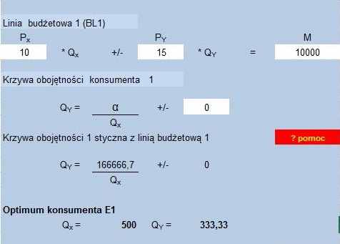
- Initial utility maximizing quantity is Q_{x}=500 and Q_{y}=333,33.

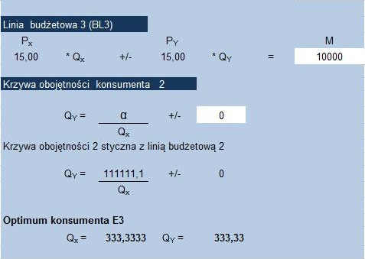
(b) New utility maximizing quantity following the increase in the price of X ceteris paribus is Q_{x} = 333,33 and Q_{y} = 333,33.
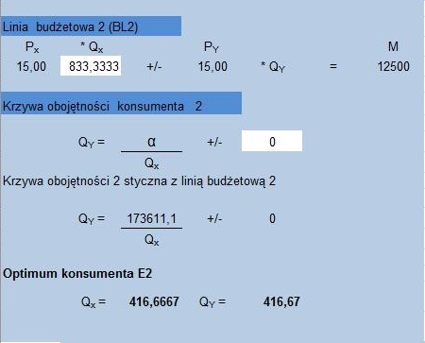

(c) To answer this question, we have to subtract initial money income from that required to consume the original bundle of goods.
That is the Slutsky comepensating variation which would allow consumer to still consume original bundle of X and Y.
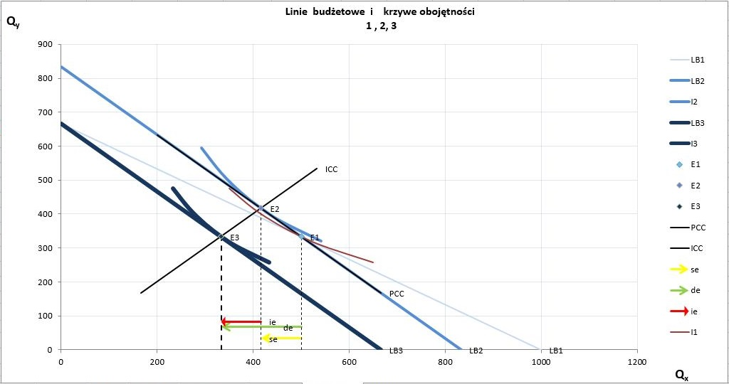
(d)
According to Slutsky derivation of substitution and income effects both of them are negative because, they are directed in opposite way to line of action of a price change. If we compound them we get aggregate demand effect which is of course also negative.
Furthermore, the income-consumption curve has a positive slope then we can state that X and Y are normal goods.
Demand curve is elastic and has a negative slope, according to this we can also say that X good is normal. It proves our previous conclusion.
