WZ UW 2016
Authors:
Gabriela Szostak
Emilia Zarajczyk

MMikro exercise
We used 7 BL-I, 10 Hicks and 11 Slutsky sheets from MMikro

Assume a person has a utility function U=XY and Money income of 10,000 $ facing and initial price of X of 10$ and price of Y of 15 $. If the price of X increases to 15$, answer the following questions:
- What was the initial utility maximizing quantity of X and Y?
Linia budżetowa 1 (BL1)
P_{x} |  |  | P_{Y} |  |  | M
10 | * Q_{x} | +/- | 15 | * Q_{Y} | = | 10000
Krzywa obojętności konsumenta 1 (I)
 | Q_{Y} = | α | +/- | 0
 |  | Q_{x}
Krzywa obojętności 1 styczna z linią budżetową 1
 | Q_{Y} = | 166666,67 | +/- | 0
 |  | Q_{x}
Optimum konsumenta E1
 | Q_{x} = | 500,0 | Q_{Y} = | 333,3

Optimal quantity for a person of those two products is 500 pc. of X and 333,33 pc. of Y.

- What is the new utility maximizing quantity of X and Y following the increase in the price
of X?
Linia budżetowa 2 (BL2)
P_{x} |  |  | P_{Y} |  |  | M
15 | * Q_{x} | +/- | 15 | * Q_{Y} | = | 10000
Krzywa obojętności konsumenta 2 (I)
 | Q_{Y} = | α | +/- | 0
 |  | Q_{x}
Krzywa obojętności 2 styczna z linią budżetową 2
 | Q_{Y} = | 111111,11 | +/- | 0
 |  | Q_{x}
Optimum konsumenta E2
 | Q_{x} = | 333,3 | Q_{Y} = | 333,3
Following the X good price increase, new utility maximizing quantity is when Qx=Qy=333,33.
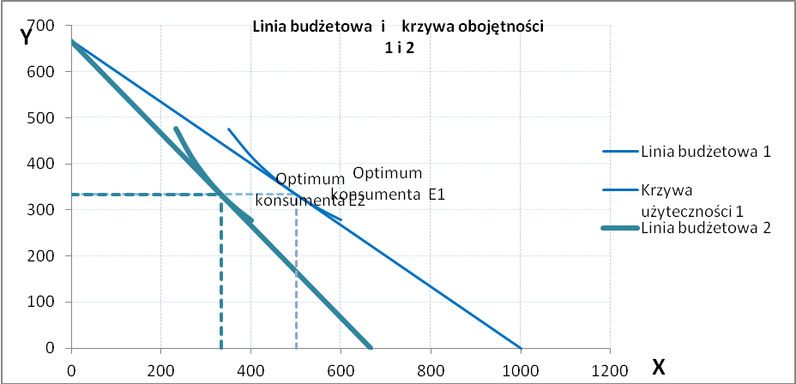
Increase in the price of good X changes the optimal quantity. Quantity of good Y is constant, but the quantity of good X decrease from 500 pc to 333,33 pc. We can notice the decrease in the amount of good X – 166,67 pc. The budget line moved to the left. The person can buy less amount of good X and the same amount of good Y. To sum up, consumer can buy less amount of goods than before.

- What is the Hicks and Slutsky compensating variation in income that would leave this person equally well off following price increase?

- Hicks
Linia budżetowa 3 (BL3)
P_{x} |  |  | P_{Y} |  |  | M
15 | * Q_{x} | +/- | 15 | * Q_{Y} | = | 12247,5
Krzywa obojętności konsumenta 2
 | Q_{Y} = | α | +/- | 0
 |  | Q_{x}
Krzywa obojętności 2 styczna z linią budżetową 2
 | Q_{Y} = | 16666,7 | +/- | 0
 |  | Q_{x}
Optimum konsumenta E3
 | Q_{x} = | 408,25 | Q_{Y} = | 408,25

Having utility function and after using the MMikro, we have the following data:

- U(x,y)=XY=166666,7
- Original income is 10,000 $
- Amount of money that must be spent to buy same amount of X&Y, but also to stay at the same level of utility is 12247,5 $

Now, we have to count the Hicks compensating variation of income :

122247,5 $ - 10000 $= 2247,50 $

- Slutsky
Linia budżetowa 2 (BL2)
P_{x} | * Q_{x} |  | P_{Y} |  |  | M
15,00 | 833,333 | +/- | 15,00 | * Q_{Y} | = | 12500
Krzywa obojętności konsumenta 2
 | Q_{Y} = | α | +/- | 0
 |  | Q_{x}
Krzywa obojętności 2 styczna z linią budżetową 2
 | Q_{Y} = | 173610,9 | +/- | 0
 |  | Q_{x}
Optimum konsumenta E2
 | Q_{x} = | 416,6663 | Q_{Y} = | 416,67

At new prices amount of money which is needed to consume the original X=500 and Y=333,33 is 12 500$. This is the money income required to allow a new budget line go through the original consumption point, so compensating variation is :
12500$-10000$=2500$

- Calculate and analyze substitution effect and income effect using Slutsky and Hicks analysis

- Hicks
Equations describing the budget lines and indifference curve:
Linia budżetowa 1 (BL1)
P_{x} |  |  | P_{Y} |  |  | M
10 | * Q_{x} | +/- | 15 | * Q_{Y} | = | 10000
Krzywa obojętności konsumenta 1
 | Q_{Y} = | α | +/- | 0
 |  | Q_{x}
Krzywa obojętności 1 styczna z linią budżetową 1
 | Q_{Y} = | 166666,7 | +/- | 0
 |  | Q_{x}
Optimum konsumenta E1
 | Q_{x} = | 500 | Q_{Y} = | 333,33

Linia budżetowa 2 (BL2)
P_{x} |  |  | P_{Y} |  |  | M
15 | * Q_{x} | +/- | 15 | * Q_{Y} | = | 10000
Krzywa obojętności konsumenta 2
 | Q_{Y} = | α | +/- | 0
 |  | Q_{x}
Krzywa obojętności 2 styczna z linią budżetową 2
 | Q_{Y} = | 111111,1 | +/- | 0
 |  | Q_{x}
Optimum konsumenta E2
 | Q_{x} = | 333,3333 | Q_{Y} = | 333,33

Linia budżetowa 3 (BL3)
P_{x} |  |  | P_{Y} |  |  | M
15 | * Q_{x} | +/- | 15 | * Q_{Y} | = | 12247,5
Krzywa obojętności konsumenta 2
 | Q_{Y} = | α | +/- | 0
 |  | Q_{x}
Krzywa obojętności 2 styczna z linią budżetową 2
 | Q_{Y} = | 166666,7 | +/- | 0
 |  | Q_{x}
Optimum konsumenta E3
 | Q_{x} = | 408,25 | Q_{Y} = | 408,25

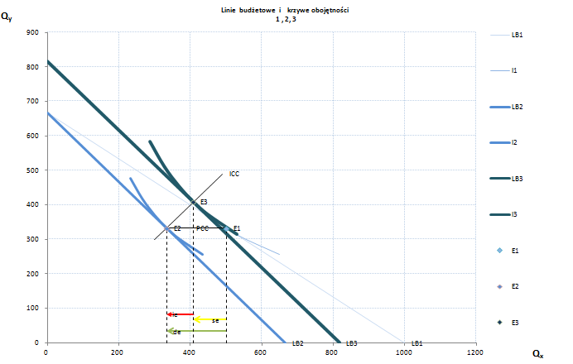

 |  | se |  | ie
 | de = | -91,75 | +/- | -74,92 | = | -166,67

Substitution effect amounts to -91,75 units and income effect is -74,92, due to X good price increase demand effect is -166,67. Increase in price of good X is causing decrease of its consumption Income effect and substitution effect are directed in the same way and demand effect is bigger than both se and ie, so X is a normal good. According to graphs, consumer income after decompensation is 122247,5 $.
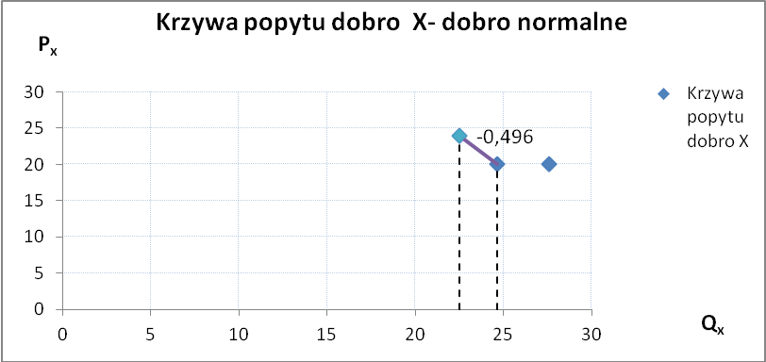

Demand curve has a negative slope. Due to ICC has positive slope and curve PCC is straight line, drawing conclusion goods X and Y are independent goods (PCC) and X,Y is a normal good (ICC).
- Slutsky
Equations describing the budget lines and indifference curve:

Linia budżetowa 1 (BL1)
P_{x} |  |  | P_{Y} |  |  | M
10 | * Q_{x} | +/- | 15 | * Q_{Y} | = | 10000
Krzywa obojętności konsumenta 1
 | Q_{Y} = | α | +/- | 0
 |  | Q_{x}
Krzywa obojętności 1 styczna z linią budżetową 1
 | Q_{Y} = | 166666,7 | +/- | 0
 |  | Q_{x}
Optimum konsumenta E1
 | Q_{x} = | 500 | Q_{Y} = | 333,33

Linia budżetowa 2 (BL2)
P_{x} | * Q_{x} |  | P_{Y} |  |  | M
15,00 | 833,333 | +/- | 15,00 | * Q_{Y} | = | 12500
Krzywa obojętności konsumenta 2
 | Q_{Y} = | α | +/- | 0
 |  | Q_{x}
Krzywa obojętności 2 styczna z linią budżetową 2
 | Q_{Y} = | 173610,9 | +/- | 0
 |  | Q_{x}
Optimum konsumenta E2
 | Q_{x} = | 416,6663 | Q_{Y} = | 416,67

Linia budżetowa 3 (BL3)
P_{x} |  |  | P_{Y} |  |  | M
15,00 | * Q_{x} | +/- | 15,00 | * Q_{Y} | = | 10000
Krzywa obojętności konsumenta 2
 | Q_{Y} = | α | +/- | 0
 |  | Q_{x}
Krzywa obojętności 2 styczna z linią budżetową 2
 | Q_{Y} = | 111111 | +/- | 0
 |  | Q_{x}
Optimum konsumenta E3
 | Q_{x} = | 333,333 | Q_{Y} = | 333,33

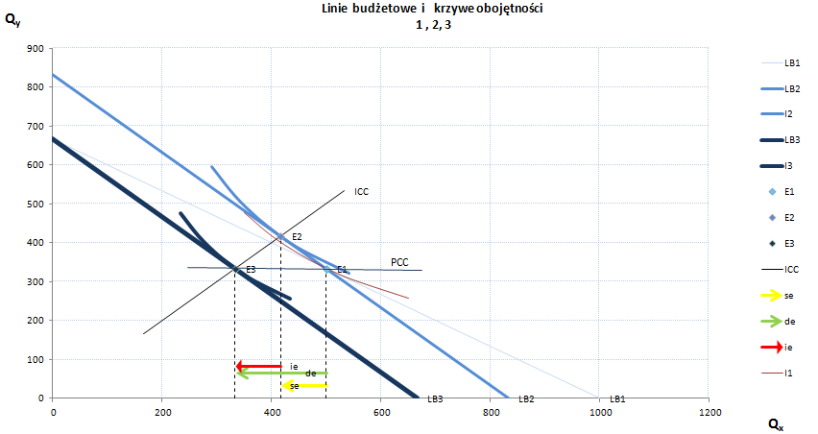
 |  | se |  | ie
 | de = | -83,33 | +/- | -83,33 | = | -166,67

Substitution effect amounts to -83,33 units and income effect is also -83,33, due to X good price increase demand effect is -166,67. Increase in price of good X is causing decrease of its consumption. Income effect and substitution effect are directed in the same way and demand effect is bigger than both se and ie. Looking at new budget line we see that consumer will buy less X and more Y.

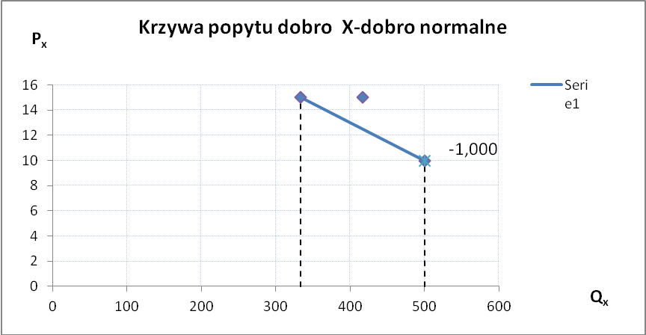
Demand curve has a negative slope. Due to ICC has positive slope , we are drawing conclusion that goods X and Y are normal goods, looking at PCC we know that X are Y are independent.
- Hicks and Slutsky
The Hicksian substitution effect is based on the assumption that consumer wants to keep the same level of utility by minimizing his expenses. The Slutsky substitution effect is based on the assumption that consumer wants to maximize the utility with the same amount of money.
In Hick’s analyses substitution effect has the amount of -91,75, income effect is -74,92 and the demand effect if -166,67. In Slutsky’s analyses substitution effect has the amount of -83,33, income effect is -83,33 and the demand effect is -166,67. How we can see, the substitution effect in Hick’s analyses is stronger than in Slutsky’s analyses. The opposite situation is with income effect. The demand effect in both analyses is the same.
To sum up X and Y are normal and independent goods.

