MICROECONOMICS PROJECT
– MMikro program

Made by :
Justyna Biedermann
Alicja Fedorczyk
Paulina Kochanowska
Karolina Popławska WZ UW 2015
We used 6 I-BL-U; 8 PCC-D sheets from Mmikro
Exercise from “Microeconomics” David Benanko Ronald R. Braeutigam
What happens to the consumer’s choice of food when the price of food changes while the price of clothing and the amount of income remain constant? Suppose the consumer’s income is $400 and the price of clothing is Py $40 per unit. Consider the consumer’s choices of food and clothing for three different prices of food. Suppose the price of food is Px1= $10, Px2=$20, Px3=$40.

Figures :
M – income
P_{x} – price of food
P_{y} – price of clothing
BL – budget line
I – consumer’s indifference curve
PCC – price consumption curve
E – optimal basket
D - demand
Data :

M = $400
Px1 = $10
Px2 = $20
Px3 = $40
Py = $40

BUDGET LINE 1
Py=40
Px1=10
Maximum amount of clothing : 400/40 = 10
Maximum amount of food :400/10=40
The optimal basket contains 16 units of food and 6 units of clothing.
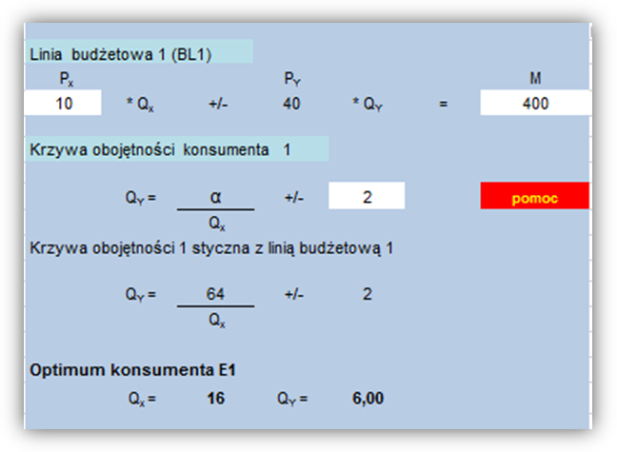

BUDGET LINE 2
Py=40
Px2=20
Maximum amount of clothing : 400/40 = 10
Maximum amount of food :400/20=20
The optimal basket contains 10 units of food and 5 units of clothing.
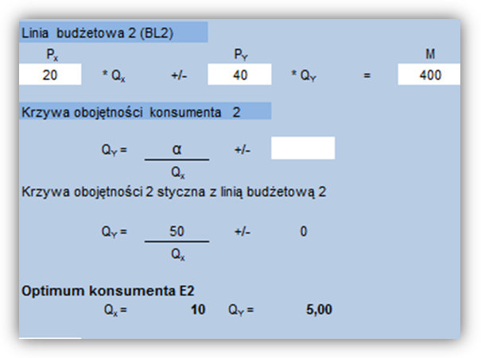

BUDGET LINE 3
Py=40
Px3=40
Maximum amount of clothing : 400/40 = 10
Maximum amount of food :400/40=10
The optimal basket contains 2 units of food and 8 units of clothing.
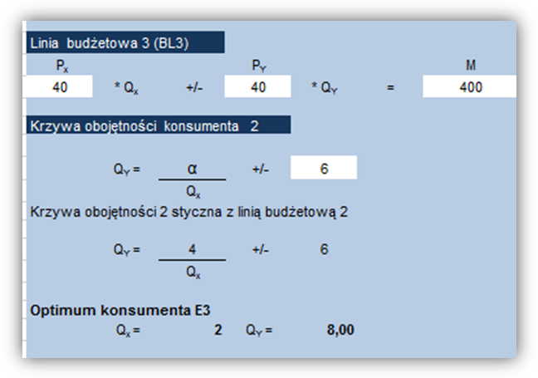

INTERPRETATION :

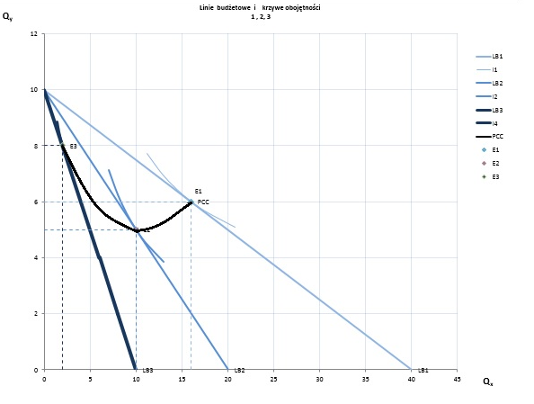

The Effects of Changes in the Price of a Good on Consumption The consumer has a income of $400. The price of clothing Py is $40.
When the price of food is $40, the budget line is BL3. When the price of food is $20 and $10, respectively, the budget lines are BL2 and BL1. The optimal baskets are E1, E2, and E3. The curve connecting the optimal baskets is called the price consumption curve. Observe that the consumer is better off as the price of food falls.
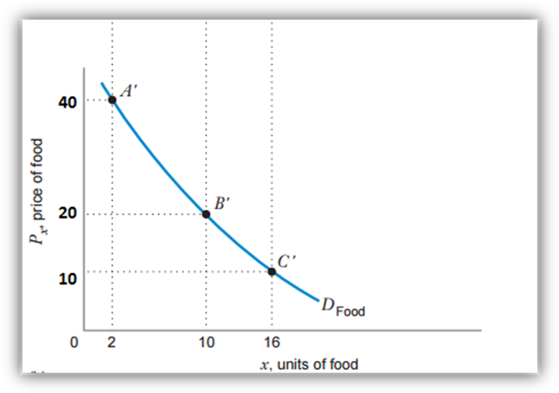
Demand curve for food (based on optimal choice diagram above). The consumer buys more food as its price falls, so the demand curve is downward sloping.

