The source: Karolina Drela, Agnieszka Kiernożycka-Sobejko, Przemysław Pluskota. 2008. Mikroekonomiczne ABC dla studentów. Publisher: Uniwersytet Szczeciński, task 10, p. 125. (slight corrections in the contents to take advantage of this assignment).
John Smith spends all his income (100 zlotys) on beer (Y) and sticks (X). The unit prices of these goods: beer costs 5 zlotys and sticks cost 7,5 zlotys. Supposing that a utility function is
- Write the consumer’s budget line, count an optimum combination of consumption these two goods and calculate a slope of his output budget constraint

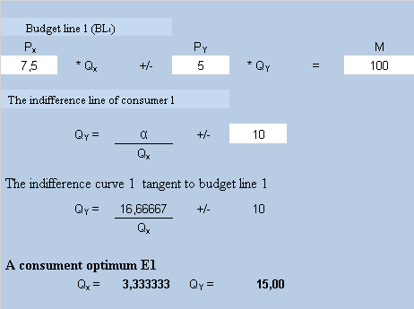

The consumer’s utility is maximized where an indifference curve is tangent to the budget line. John maximizes his satisfaction from consumption, purchasing 3,33 bundles of sticks and 15 beer tins.
The slope of budget line BL₁: 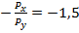
- How will the position of budget line change, when the price of a bundle of sticks (X) will decline to 4 zlotys?
- Taking into account J. R. Hicks’ theory, count a substitution effect, an income effect and a total effect of the price change of sticks, and derive price-consumption curve (PCC), income-consumption curve (ICC) and a demand curve for good X.

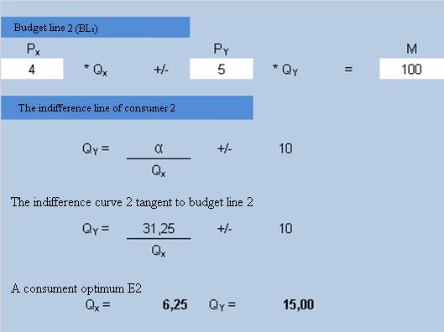
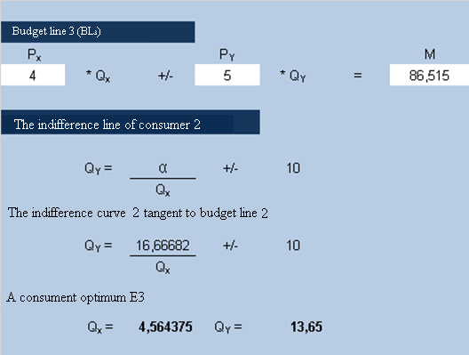

The interpretation:
We receive the Hicks substitution effect, moving parallel the new budget line (LB₂) towards an output indifference curve. In order to do this, the income (M) has to be changed in a way to obtain an indifference line from output conditions. The John’s income after decompensation amounts to M = 86,52 zlotys (LB₃). If the price of good X declines (ceteris paribus), the amount of demand for this good increases. Graphically the price decrease of good X shows the translation of the budget line on the right towards the axis of abscissas (from BL₁ to BL₂).
LB₂ – higher real income (we can buy more of good X)

The substitution effect of price decrease of good X amounts to 1,23 units, whereas the income effect is 1,69 units. The income effect (ie) and the substitution effect (se) are directed in the same way, therefore good X is a normal one. The total effect (de) amounts to 2,92 units of good X.
de = se + ie
de = 1,23 + 1,69 = 2,92
Good X is a normal one, as we have already proven. It means that the Hicks substitution effect is negative (the inverse correlation between price and consumption – the price decreases, the consumption increases), while the income effect is positive (the increase of real income has caused the increase of consumption). Generally speaking: the negative substitution effect is enhanced additionally by positive income effect. As a result of that the total effect (caused by the price decline of good X) results in the demand increase for this good.
The price decrease of good X caused the increase of good X consumption amounts to 2,92 units.
Income-consumption curve has a positive slope (which means these goods are normal)
Price-consumption curve is parallel to the axis of abscissas, so it has neutral scope – goods X and Y are independent. A price change for one has no effect on the demand for the other.
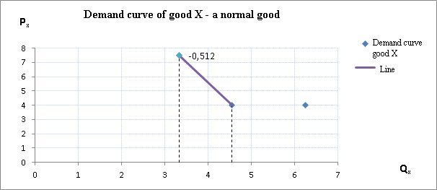

The demand curve for good X has a negative scope. The income effect and substitution effect move in a opposite direction against price change of good X. It determines the direction of total effect price change of good X.

