2016 W. Zarządzania UW
dobro/usługa | Czas | miejsce
service | Sezon | dowolne

Law of demand and supply on the market of diet caterings



RESEARCH PROBLEM

Verification of law of demand and supply on the market of diet caterings on assumption of 2000 kcal per day, for one week, which was conducted in Warsaw in 2016 among research group consisting of people in age 19-50.

Research goal

- Examining how do the demand and supply work on the market of diet caterings.

Main hypothesis
Prices of diet caterings depend on the law of demand and supply

I Detailed research hypothesis
- The linear nature of the demand function. .
- The linear nature of the supply function. .
II Detailed research hypothesis
- The occurance of the law of the demand and supply at the same time lead to equilibrium on the market.

STUDY POPULATION
We asked the group of 55 people:
- Age of people: 19-50
- Students and employed people
- Residents of Warsaw

THE METHOD OF RESEARCH

The survey was conducted among consuments:
- How much you would be able to spend on diet catering for one week?
- Searching for data of supply on the market of diet caterings

Procedure of survey

- Prices are in PLN
- We take into account diet caterings consisting of 2000 kcal per day for one week

TIME AND WAY OF CONDUCTING THE SURVEY

The research was done among 55 people through Messagener and by telephone in term 16-19.11.2016. Supply was examined among 22 warsaw diet caterings

RESEARCH RESULTS

How much you would be able to spend on diet catering for one week?

Max price | 189 | 300 | 395 | 440 | 570
Quantity of people | 19 | 14 | 12 | 7 | 3

Minimal price for diet catering (determined by sellers)

Minimal price | 189 | 300 | 395 | 440 | 570
Quantity of people | 1 | 2 | 5 | 6 | 8

ANALYSIS OF DATA COLLECTED

After entering data functions of demand and supply looks like:

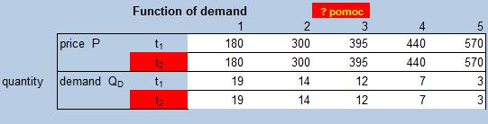

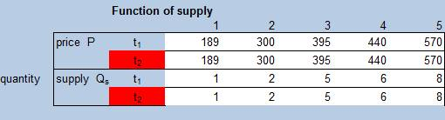

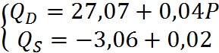

EVALUATION OF DETAILED HYPOTHESIS

I Detailed hypothesis

- The linear nature of the demand function.

Function of demand is:

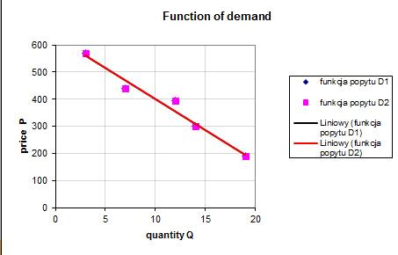

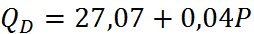

Coefficient of the function-data adaptation: .
It satisfies the condition that , and therefore this detailed hypothesis is true.

- The linear nature of the supply function. .

Function of supply is:

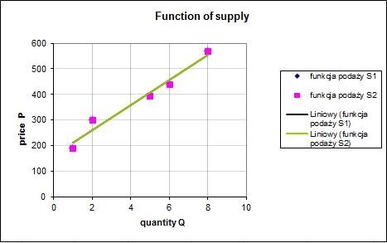

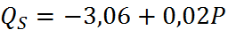

Coefficient of the function-data adaptation is: .
It satisfies the condition that , and therefore this detailed hypothesis is true.

II Detailed hypothesis

- The occurance of the law of the demand and supply at the same time lead to equilibrium on the market.

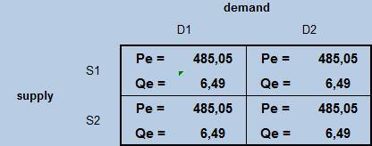

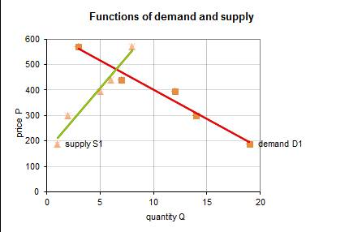

The equilibrium on the market is:
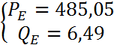

CONCLUSION

After the research and analysing the collected data it turned out that average price for service of diet catering is 485 PLN. It proves that Main Hypothesis:

‘Prices of diet caterings depend on the law of demand and supply’

is true.

Magdalena Gojdycz, Iga Kraśniewska, Katarzyna Sawicka

