Faculty of Management, University of Warsaw 2016
goods/service | period of time | place
normal necessity goods | optional | Warsaw

Microeconomics term paper

DEMAND AND SUPPLY ON THE MARKET OF A LARGE PEPPERONI PIZZA

Anna Boruch (nr 385902)
Magdalena Celarska (nr 385930)
Zuzanna Kosiarska (nr 386541)
Agnieszka Kwiecińska (nr 371776)

Research problem:
Practical verification of how the law of supply and demand applies to the market of a large pepperoni pizza which is based on a survey of a group of 50 students from the Faculty of Management in November 2016.
Research goals:
1. Verification of the existence of the law of demand and supply on the market of a large pepperoni pizza.
2. The simulation aims to contribute to the students’ data base in the category of SUPERIOR GOODS.

Main hypothesis:
Prices and quantities available in the market of large pepperoni pizza depend on the law of supply and demand.

Detailed research hypothesis I
Linear nature of the demand function
Linear nature of the supply function.

Detailed research hypothesis II

On the market of large pepperoni pizza there exists a state of equilibrium in accordance to the law of supply and demand.

Detailed research hypothesis III
The type of a good can be determined by the analysis of the price elasticity of demand and supply in the point of the equilibrium. If the price elasticity of demand in the equilibrium is below 0 (Epd<0), the demand function is inelastic and the good can be determined as a superior goods. If the price elasticity of supply in equilibrium is above 0 (Eps>1) the supply function is categorized as highly elastic.

Study population:

Group of 50 people:
- Age: 19-25.
- Students of Faculty of Management
- Residents of Warsaw

Methodology of the test
- The data on the demand has been collected from the population of students by a survey which consisted of one question:
How much would you be able to spend on a large pepperoni pizza?
- The data on supply has been collected from the menus of existing pizza restaurants in Warsaw

The simulation has been performed under following assumptions:

- Large pepperoni pizza.
- Warsaw market.

Date and procedure of survey:
The survey took place on Facebook in November 2016. We collected information about the prices from Warsaw pizza places.

Survey results:
Question to interviewees:
How much would you be able to spend on large pepperoni pizza? (Price PLN).
Maximal price | 21 | 29 | 32 | 40 | 45
Amount of people | 50 | 40 | 30 | 20 | 10

Prices offered by producents.
Minimal price | 25 | 27 | 29 | 31 | 36
Amount of people | 7 | 14 | 21 | 28 | 35

Analysis of data collected:
The results of implementation of the data to the model:

The charts present the demand and supply functions.
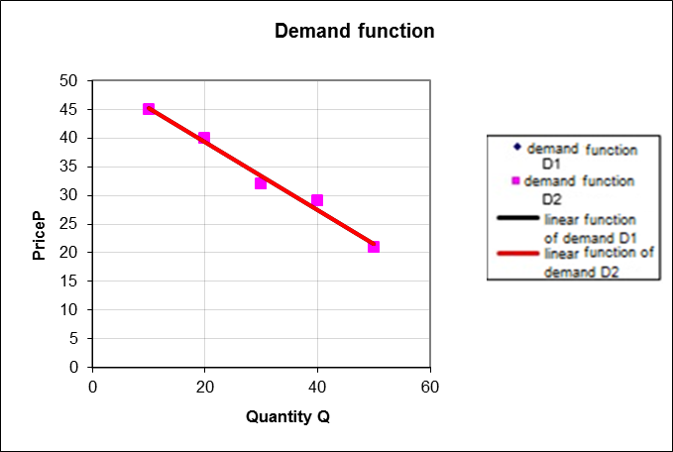

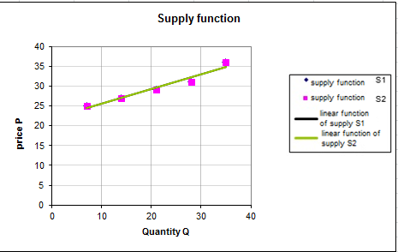

Interpretation of the result:
The results of implementation of the data to the model:
Qᴅ=85,79-1,67P
Qs=-54,66+2,56P

Evaluation of the detailed hypotheses:

Detailed research hypothesis I
- Linear character of the demand function.
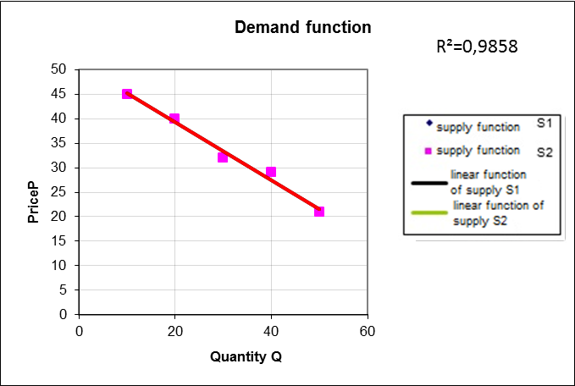
Demand function: Qᴅ=85,79-1,67P.
Coefficient of the function-data adaptation: .
It satisfies the condition that , and therefore this detailed hypothesis is true.
- Linear character of the supply function .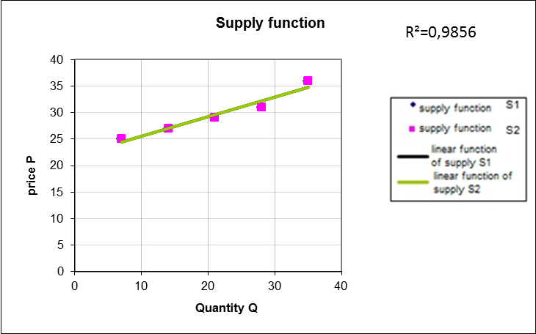

Supply function: Qs=-54,66+2,56P.
Coefficient of the function-data adaptation is: .
It satisfies the condition that , and therefore this detailed hypothesis is true.
Detailed research hypothesis II

On the market of large pepperoni pizza there exists a state of equilibrium in accordance to the law of supply and demand.

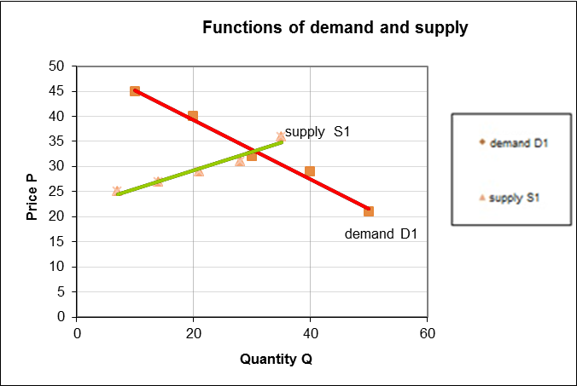

The equilibrium on the market of large pepperoni pizza is achieved at a price of 33,23 PLN. At this price level: demand = supply = 30,28 units.
Pe = 33,23
Qe=30,28
Having analysed the data from the pizza market, we were able to determine that the average price of a large pepperoni pizza is 30,28 PLN. Therefore, the theoretical mechanisms of the market exist in the reality.

Detailed research hypothesis III

We apply demand function and supply function to the program to calculate price elasticity of demand and supply at the point of market equilibrium.

Interpretation of the result:
Price elasticity of demand at the equilibrium is:
Epd= -1,83
The demand for large pepperoni pizza is elastic, so that a change of price by 1 unit causes the demand to change by -1,83 of the price change.
Price elasticity of supply at the equilibrium is:
Epd= 2,80
Supply of large pepperoni pizza is highly elastic. At the equilibrium the price is 33,2 PLN. Each change in price causes the supply to change by 2,8 of the change of price.
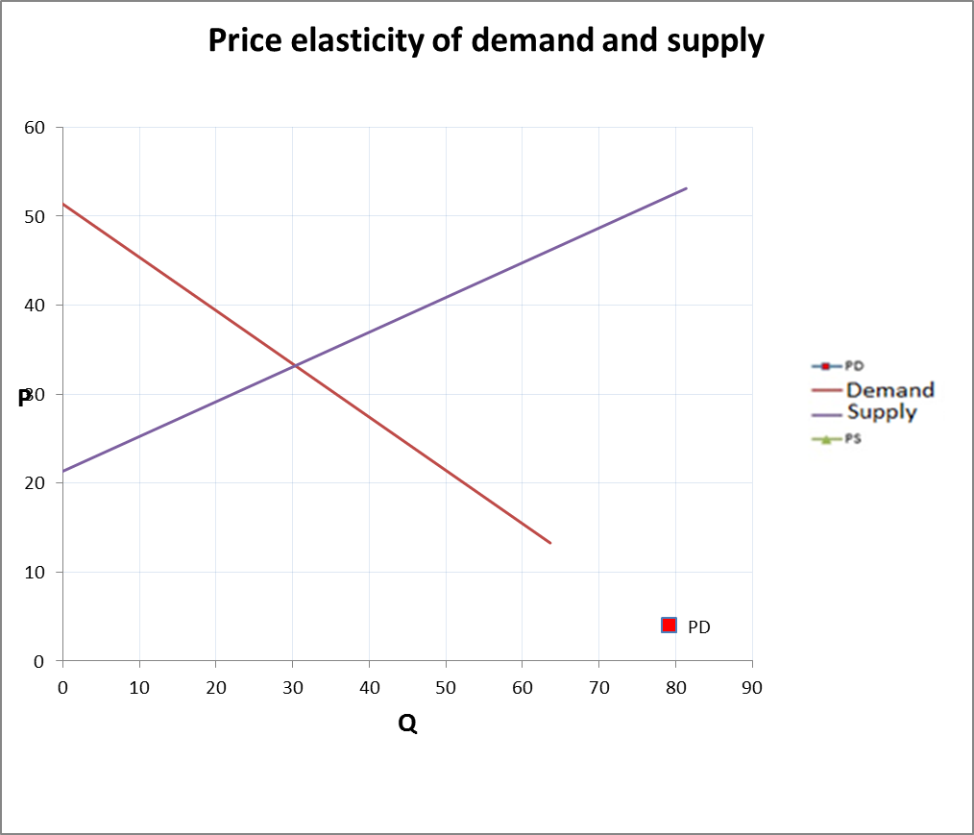
Each change of the price of a pizza is followed by a greater change in demand and supply; therefore it proves that the demand and supply are elastic and that the large pepperoni pizza is a superior good.
Conclusion:
Having analysed the collected date, we were able to prove all the detailed research hypotheses to be true. Therefore, the main research hypothesis - Prices and quantities available in the market of large pepperoni pizza depend on the law of supply and demand, has been proven and becomes a thesis. It is yet another example confirming the existence of the law of demand and supply.

Attachment 1.
Information about the supply has been collected from Warsaw pizza places, which offer large pepperoni pizza.
- La Torre,
- Pizzeria Nowoursynowska ,
- Pizzeria na Nowolipkach,
- Pizzeria u Dziadka,
- Domino’s Pizza,
- Da Grasso,
- Bella Napoli Spagheteria,
- Pizza Hut,
- Pizzeria Caramba,
- Vero Pizza,
- Gusto Dominnium,
- Antonio Pizza & Pasta,
- Don Vito,
- Chicagos Pizza,
- Pizzeria Napoli
- Pizzeria Gaga,
- La Stella,
- Pepperoni Pizzeria,
- Rimini,
- Kosmiczna Pizza,
- First Pizza,
- Pizzeria Prato,
- Pizzeria po zmroku,
- Pizzeria nocą,
- Pizzeria Dodo,
- Pizzeria Gang Leona,
- Pizzeria Vera,
- Maxi Pizza,
- Pizza przy Politechnice,
- Pizzeria Rosso,
- La Verona,
- Otto Pizza,
- Primo Pizza
- Telepizza
- Pizzeria il Vegabondo

