
Law of demand and supply on the ski market

Wydział Zarządzania Uniwersytetu Warszawskiego
Semestr 2016/2017Z
good | time | place
normal goods | October and December 2016 | no preference

Authors:
- Daniel Pańczyk (388019)
- Urszula Witaszek (388489)
- Krystian Tracz (388400)
- Michał Buszko (386142)

Research problem

Verification of demand and supply laws on the market of winter sports equipment, in two periods of research, in 2016.

Research goals

- Analysis of demand and supply laws on the market of skis.
- Element of student's database of essays created to verificate demand and supply laws on different markets - category normal goods.

Main hypothesis

Prices and quantities available in the market of skis depend on the laws of supply and demand.

Detailed research hypothesis I
Linear character of the demand function on the market of skis. (R²>0,6)

Detailed research hypothesis II
Linear character of the supply function on the market of skis. (R²>0,6)
Detailed research hypothesis III
With the change of the customer’s needs, which stems form the diversity of periods of research, demand and supply on the market od skis change.

Detailed research hypothesis IV
Elasticity of demand and supply in the point of market equilibrium shows with which good are we dealing with.
Research sample
Subject of the research is a group of 30 people chosen according to the following criteria:
- Age: 18-60
- Residents of Poland
- Skiing amateurs
Research methods
Survey carried out in two periods od research included two questions:
- Which is the highest price you would like to pay for skis?
- Which is the lowest price you would like to sell skis?
With the following criteria:
- Skis are not used
- Mid-price
Date and the method of conducting the survey
The survey was conducted for the first time in October and then again in December. Survey included two questions that have been asked to a similar research grup, on social networking site – facebook, among the grous of people interested in skiing.
Results of survey
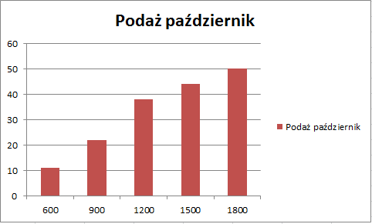
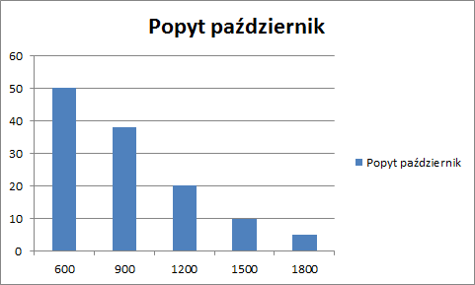

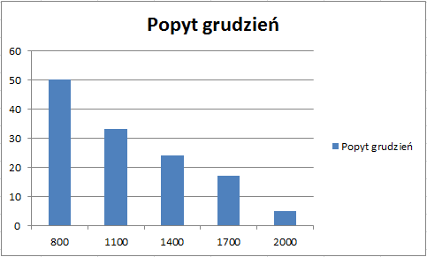
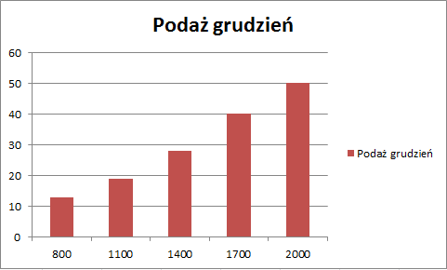

Analysis of collected data
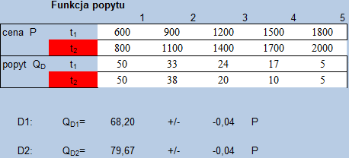

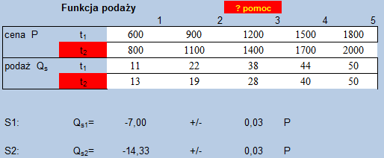
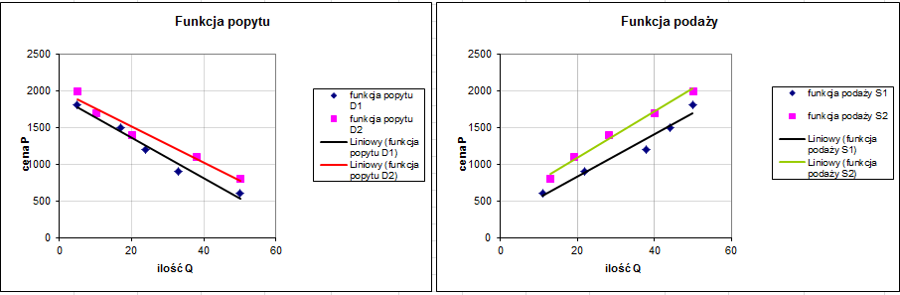
Supply and demand functions, most relevant to the real data:
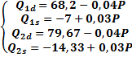
October
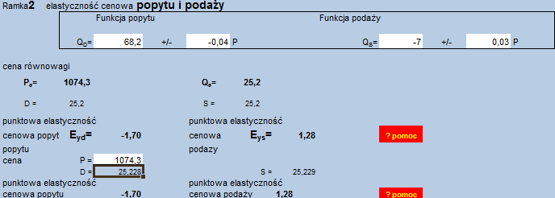
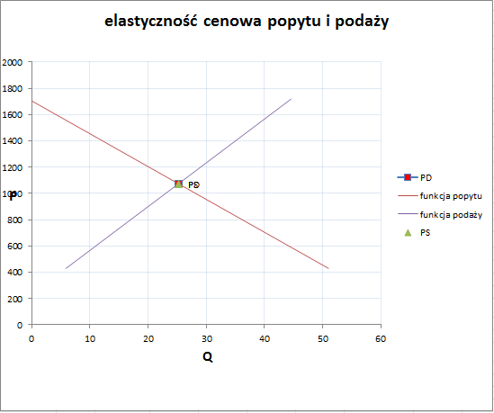
In October, the absolute value of the price elasticity of demand in the point of market equilibrium is > 1, which means that the price increase of one percent will cause a drop of demand of more than one percent, which implies that the skis are a superior good.

In October, the absolute value of the price elasticity of supply in the point of market equilibrium is > 1, which means that the price increase of one percent will cause an increase of demand of more than one percent.
December
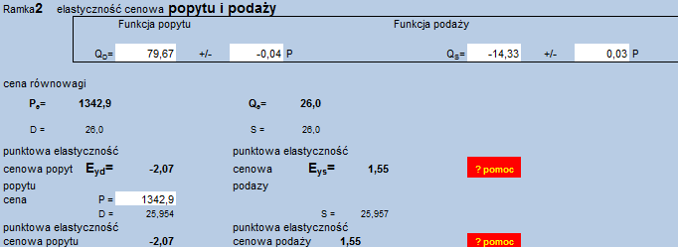

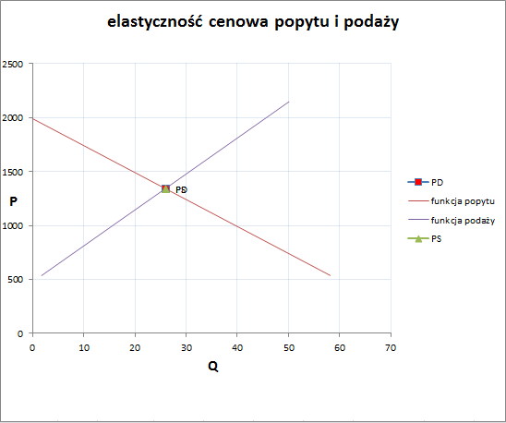
In December, the absolute value of the price elasticity of demand in the point of market equilibrium is > 1, which means that the price increase of one percent will cause a drop of demand of more than one percent, which implies that the skis are a superior good.

In December, the absolute value of the price elasticity of supply in the point of market equilibrium is > 1, which means that the price increase of one percent will cause an increase of demand of more than one percent
Price elasticity of demand, in December, in the point of market equilibrium is higher than in October, which means that in December skis are a more desirable product.
Verification of detailed hypothesis:

Detailed research hypothesis I
Linear character of the demand function on the market of skis. (R²>0,6)
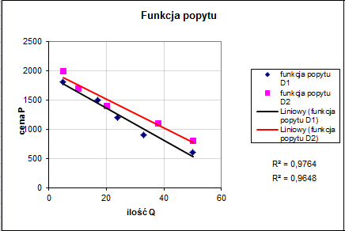

Functions of demand:

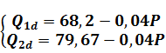
The coefficients of of the function data adaptation are: R₁² = 0.9764 and R₂² = 0.9648.
They therefore comply with a condition that R²>0,6, which proves that there is a linear correlation between the price and demand in the market of skis.

Detailed research hypothesis II
Linear character of the supply function on the market of skis. (R²>0,6)
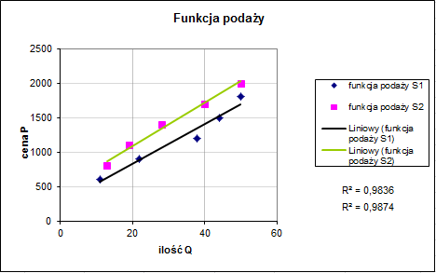

Functions od supply:

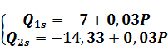

The coefficients of of the function data adaptation are: R₁²=0,9836 and R₂²=0,9874.
They therefore comply with a condition that R²>0,6, which proves that there is a linear correlation between the price and supply in the market of skis.

Detailed research hypothesis III
With the change of the customer’s needs, which stems form the diversity of periods of research, demand and supply on the market od skis change.
The attached graphs clearly show the diversity of consumers behaviors, depending on the periods of research. The demand for ski equipment is increasing in the season of winter sports. The reaction to this behavior is the increase of the prices of those products which leads to the increase of supply.

Detailed research hypothesis IV

Elasticity of demand and supply in the point of market equilibrium shows with which good are we dealing with.

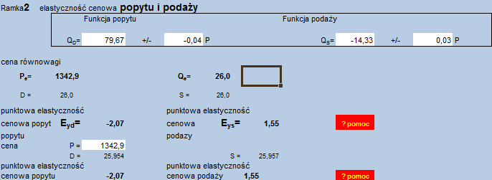
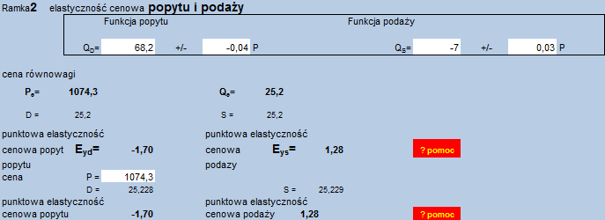
Price elasticity of demand at the equilibrium is:
In December:
E_{d}=-2,07
In October:
E_{d}=-1,70
Demand for this good is highly elastic in both: October and December. It means that every change in the price will cause a percentage change in the demand of over one percent of the change of price.
This means that we are dealing with superior good.

Conclusion
After a deep analysis of the collected data we managed to prove that all the detailed research hypotheses are true. Which also shows that prices and quantities available in the market of skis depend on the laws of supply and demand.

Glossary:
Cena - Price
Ilość - Ouantity
Popyt - Demand
Podaż - Supply
Elastyczność – Elasticity
Funkcja - Function

