
MICROECONOMIC ANALYSIS;
PERSONAL TRAINER
Authors
Jan Jastrzębski
Konrad Byliński – nr. albumu 376374
Mateusz Wargin – nr. albumu 376704

Assignment nr 1
Functioning of the market
The object of our simulation is the subject operating on recently created market of online fitness instructors, which probably does not have a real brand name on its own yet. For the working purposes it will be referred to as “Market of online fitness instructors.”
Our subject is a personal trainer planning on starting his business “online” i.e. selling his training advices on the internet. Our main target was to find the economic equilibrium of that market.
To determine the relationship between the price of product, and its supply forward measures had to be taken:
1. Survey among 50 potential customers had to be carried out. Customers were chosen based on their social networking sites activity.
One of the key factors was customer’s declaration of participation in events such as: “I will start working out in 2016”;“ After new year’s eve I’ll go on a diet” and so on, which was a sign of their potential need for a personal trainer.
Second factor was a lack of knowledge in nutrition, bodybuilding and fitness industry. That was determined by asking each of the participants personally. We aimed to create a uniform research group, and to follow the instructions provided by the supplier (trainer) as it is supposed to be his target group.
Selected group of 50 potential customers was given a brief explanation on range of services provided by the trainer, and asked a simple question:
“How much are you willing to pay for the services of personal trainer online for a month?
a) 100 zł
b) 150 zł
c) 200 zł
d) 250 zł
e) 300 zł”
All the prices above were given by the trainer we cooperated with.
2. Assessment of the “production capabilities” of the said subject.
The only factor influencing the production capabilities was time. Our supplier had only 15 hours a week to offer.
There is an interesting relationship between the price of the product and its cost in form of time, in this event. Depending on the price paid the level of personalization of the training plans and diets changes. This, as a result, extends the time needed to create one. This affected the overall look of the quantity curve.
To clarify, difference between products in given prices is not as visible for customers. They only see the amount of money that needs to be paid. The fact that the product for 300 zł costs the trainer more working hours than the one for 100 zł is irrelevant for the customers (they are not aware). Customers from the target group are, as it was mentioned, lacking knowledge in fitness industry, so they cannot tell the difference between a well-made plan and a poorer one. Furthermore, the alternative cost in said case does not exist for the customers as they do not know of any other amount of personalization. It was never revealed to them.
Next, our work had two tasks. First was to supply our friendly trainer with microeconomic charts in order to optimize the price of his services. Second to prove few vital hipothesis.
Hypothesis I
There is a linear-relationship between a price and quantity on the market of online fitness instructors.
Hypothesis II
Application of law of demand and law of supply results in the creation of point of equilibrium on the market.
Hypothesis III
Elasticity of demand and supply in equilibrium shows the type of good.
To create this presentation program „1PopPod” and MMikro was used. The analysis concerns only the potential material benefits in short period.
After gathering all the data and transferring it to the program following charts on function of demand and supply were created:
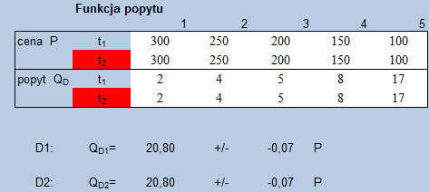
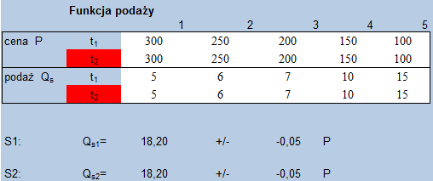
Glossary for tables can be found at the end of the paper.

Function of demand:
Qd= -0,07P+20,80
Function of supply:
Qs= -0,05P-18,20

Thanks to the program the necessary calculations were done automatically. Thus the following was concluded: R² equals for the demand and supply as follows: 0,9891 i 0,9809. Both are greater than 0,6, which proves hypothesis I.

As shown on graph:
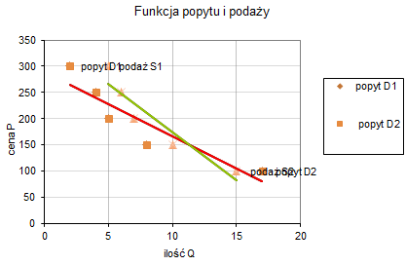
As seen above, the graph of supply is, extraordinarily, decreasing. This is due to the interesting phenomena we mentioned before. The only cost of production is limited time, and with its increase, the price of time rises.
The point of intersection occurs:
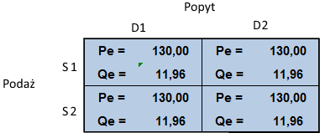
Equilibrium occurs when price equals P=130 zł and amount of clients equals Q=11,96 (what can be rounded to 12)
Graph shows the point of intersection between demand voted by the clients and supply provided by trainer. Applying adequate microeconomic formula reveals the ponit of equilibrium. Hypothesis II has been proven.
Po wprowadzeniu danych do programu 4ElastyczPopPod otrzymaliśmy tabelę:
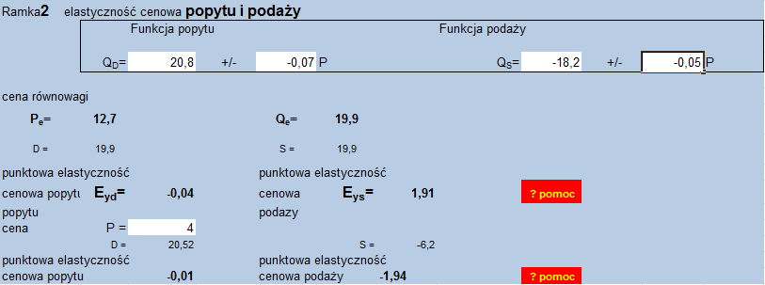
It shows:
Price elasticity of demand at the point of equilibrium is:
E_{pd}=-0,04
The demand is inelastic, stiff in terms of price.
Price elasticity of supply at the point of equilibrium is:
E_{ps}=1,91
The supply is elastic in terms of price.
Thanks to the information provided by the data above, and microeconomic knowledge we can easily determine the type of good which is being analyzed. Thus proving the last hypothesis number III.
Glossary
Cena – price
Elastyczność – elasticity
Funkcja – function
Ilość – quantity
Podaż – supply
Popyt – demand

