2015 W. Zarządzania UW
dobro/usługa | czas | miejsce
normal necessary goods | sezon | dowolne

LAW OF DEMAND AND SUPPLY ON THE MARKET OF SANTA HATS

rESEARCH PROBLEM
Practical verification of how the laws of supply and demand are working on the market of Santa hats, which would have been purchased on December 2015 by people living in Warsaw.

RESEARCH goals
- Checking the functioning of law of demand and supply on the market of Santa hats
- It is the part of the student’s researches, which are focused on the analysis of laws of supply and demand in different markets - category NORMAL NECESSARY GOODS.

Main HYPOTHESIS

Prices and quantities available in the market of Santa hats depend on the laws of supply and demand.

Detailed Research Hypothesis I
The linear nature of the demand function. .

Detailed Research Hypothesis II
The linear nature of the supply function. .

Detailed Research Hypothesis III
Price elasticity of demand function and supply function on the market of Santa hats is highly flexible during the holidays.

study population
We asked the group of 50 people:
- Residents of Warsaw
- Age of respondents: any,unrestricted

The METHOD of the test
The survey consists one query to the potential buyer:
How much would you be able to spend on red velvet and trimmed with white fur Santa hat?
The query to seller:
How many Santa hat would you be able to provide at suggested price?

DATE AND PROCEDURE OF SURVEY
The survey was conducted personally on the most popular street in Warsaw called Krakowskie Przemieście. We have selected randomly the group of 50 people, who were so kind to answer our questions.
Information about the size of the supply were given by Ms. Margaret Bronkiewicz in the Art Studio of hats in Rzeszow (link: www.facebook.com/ArtystycznaPracowniaModniarska).
The research was carried out on 6th of December 2015.

SURVEY RESULTS
How much would you be able to spend on red velvet and trimmed with white fur Santa hat?
Price | 10 | 15 | 20 | 25 | 30
Amount of people | 23 | 16 | 6 | 3 | 2

How many Santa hat would you be able to provide at suggested price?
Price | 10 | 15 | 20 | 25 | 30
Amount of hats | 0 | 2 | 5 | 15 | 28

ANALYSIS OF DATA COLLECTED
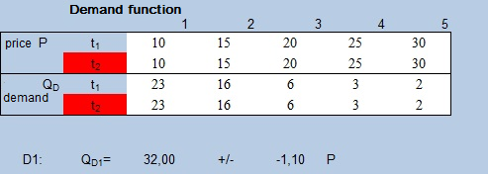

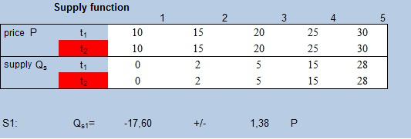

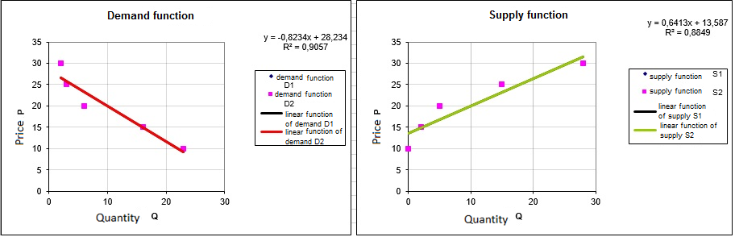
Demand function:
Inverted form of the equation of supply:

Supply function:
Inverted form of the equation of supply:
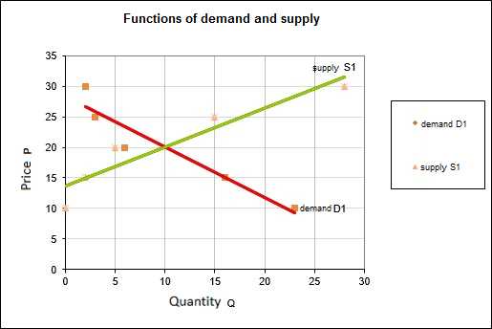
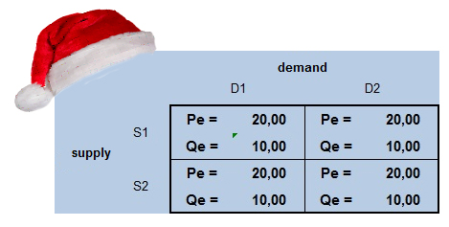
The equilibrium on market of Santa hats is achieved at the price of 20 PLN.
At this price level: demand= supply= 10 units

Evaluation of the detailed hypotheses

Detailed research hypothesis I
Linear character of the demand function.
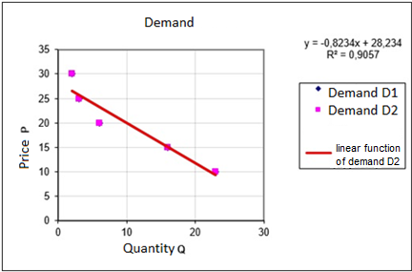
Coefficient of the function-data adaptation: .
It satisfies the condition that , and therefore this detailed hypothesis is true.

Detailed research hypothesis II
Linear character of the supply function .
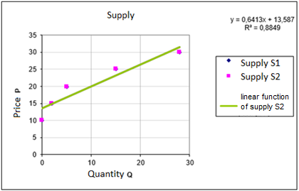
Coefficient of the function-data adaptation is: .
It satisfies the condition that , and therefore this detailed hypothesis is true.

Detailed research hypothesis III
Price elasticity of supply and demand for Santa hats during Christmas time is high.
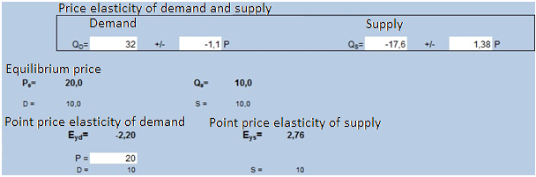
Price elasticity of demand at the equilibrium is:
Demand for Santa hats is highly elastic. It means that every change in the price will cause a percentage change in the demand that is -2,20 of the change of price. We can conclude from this high price elasticity that Santa hat is an example of a superior good.
Price elasticity of supply at the equilibrium is:
Supply of Santa hats is highly elastic. At the equilibrium price 20 PLN, every change in price will cause a percentage change in supply that is 2,76 of the change of price..
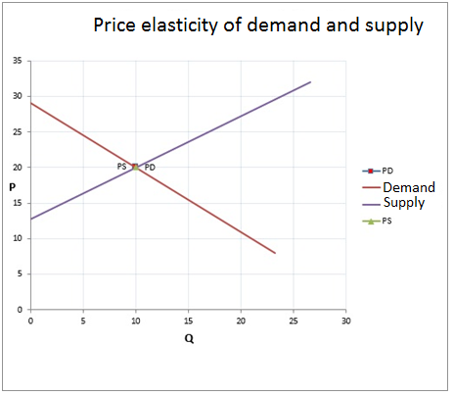

Price elasticity of demand is -2,20 and price elasticity of supply of Santa Claus hats during Christmas time is 2,76 – both are highly elastic, and therefore this detailed research hypothesis is true.

Conclusion
After analysing the collected data, we managed to prove all the detailed research hypotheses to be true. Therefore the Main Research Hypothesis:

Prices and quantities available in the market of Santa hats depend on the laws of supply and demand.
…has been proven and has become a thesis. It is yet another example confirming the existence of the laws of demand and supply.


HAVE YOU LOST YOUR HAT AGAIN?

